**Lesson01 What is the Azure Storage Account**

**Notes: -**

**1-Azure Storage is azure services which used to store images , files ,etc.**

**(suppose you have web application and hosted on VM and you need to upload images , it’s not realizable to upload to VM because if VM down all data may be lost , so the solution is use azure storage services like Blob service to store images and documents)**

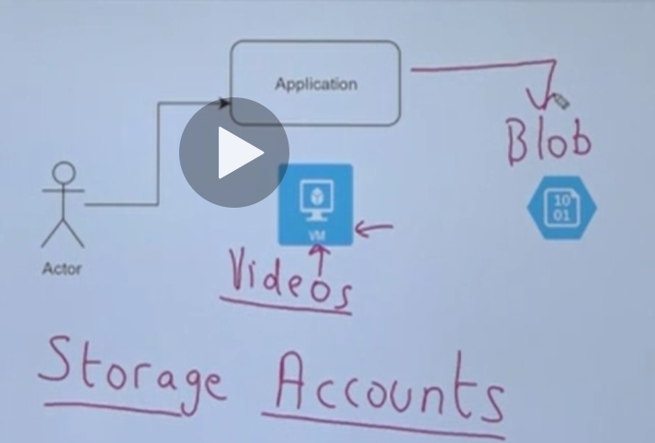

**Advantage of using Azure Storage service**

**A-Decupling: which means that the azure storage is separated from the VM and web application**

**B-Azure service provide high available, high reliable, high scalable service**

**Azure storage services Introduction**

**1-Disk Storage service : which used to store data as disk files VM via VHD storage**

**2-Tabe Storage service : which used to store data in table declared in table storage service and provide quick access to data**

**3-File service : provide file shares that can be access by different users / VMS**

**4-Queue service : used to receive and sending messages**

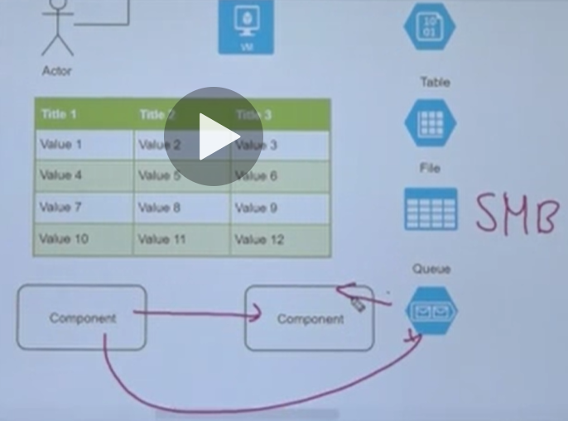

**Types of Azure Storage Services**

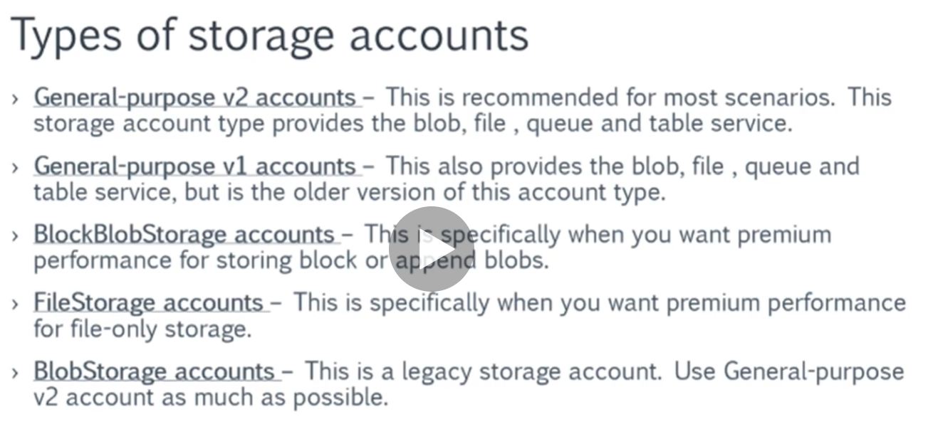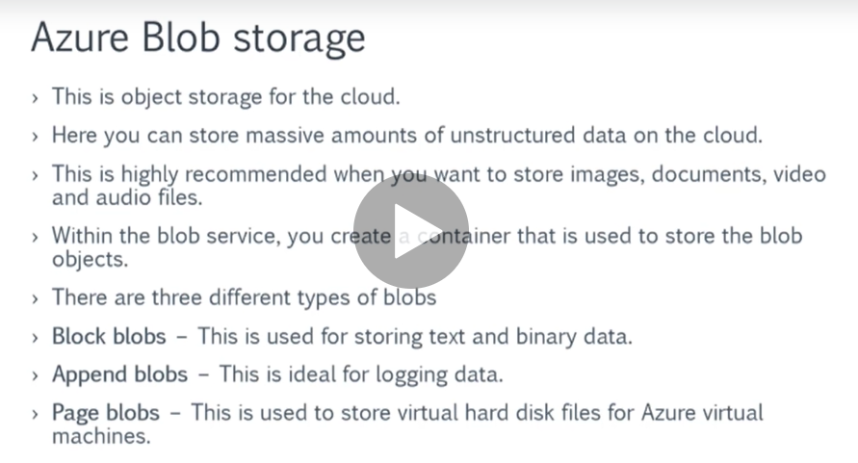

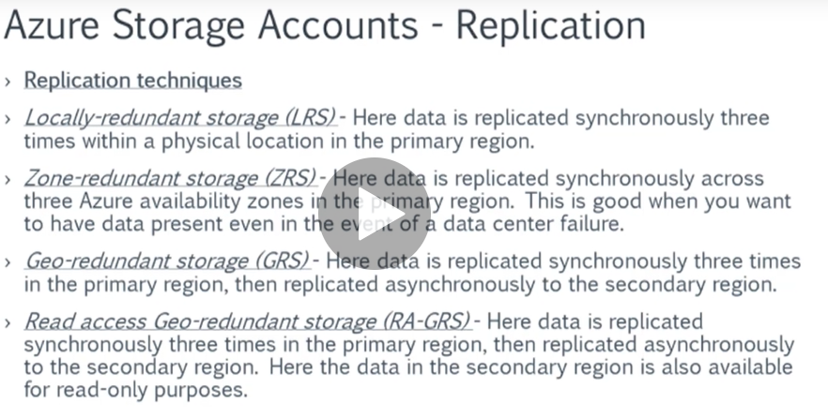

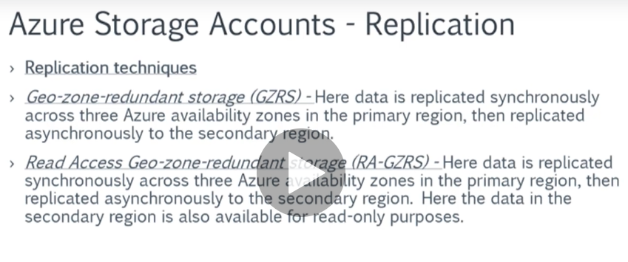

**LRS => make 3 copies of blob in the same region > same available zone**

**ZRS => make 3 copies of blob in the same region > different available zone**

**(more recommended)**

**GRS => make 3 copies of blob in same region > same available zone**

**+ 3 copies of blob in secondary region > secondary available zone (High Cost)**

**RA-GRS => (Read Only) make 3 copies of blob in same region > same available zone**

**+ 3 copies of blob in secondary region > secondary available zone (High Cost)**

**GZRS => make 3 copies of blob in same region each one in different available zone**

**+ 3 copies of blob in secondary region each one in secondary available zone**

**GZRS => make 3 copies of blob in same region each one in different available zone**

**+ 3 copies of blob in secondary region each one in secondary available zone**

**(but in secondary region the data is read only)**

